



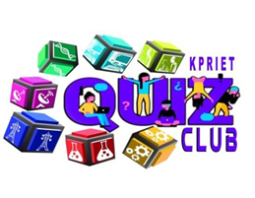

**“KPR Unacademy Combat”- Report**

Our KPRIET Quiz club & Master Academy successfully completed the **KPR** **Unacademy Combat** event through online on 28/01/2021, from 11 am to 12.30pm through Unacademy platform. Totally we had received around 280 responses. Finally, Top 10 winners were rewarded with a cash prize. We had received good feedback from the participants. The quiz contains 20 questions which is useful for GATE Exam and other competitive exams. This event gave an idea to approach all the logical reasoning questions in competitive exams. Many other participants gave their valuable participation to this event. Our coordinators gave their wonderful support and contribution to this event.

**Staff Coordinators:**

Mr.G.Pradeepkumar-AP (Sr.G)/ECE

Dr.S.Kanmani – ASP/ CIVIL

**Student Coordinators:**

Bharathwaj N- III EEE

Rohini C S –II ECE

**Prize Winners:**

1. Ashfa - Rs.500
2. Anjali - Rs.500
3. Subham - Rs.400
4. Rithika - Rs.400
5. Mathushree - Rs.300
6. Karthi - Rs.300
7. Pavithra R - Rs.200
8. Monika - Rs.200
9. Bibhas - Rs.100

10.Charan- Rs100

**Feedback Responses:**

Thank you for conducting this event. It was useful & some money prizes are given for encouraging students to participate in upcoming events – ANJALI

Quiz club were giving full dedication and effort for all events. - RITHIKA

**Event Poster:**

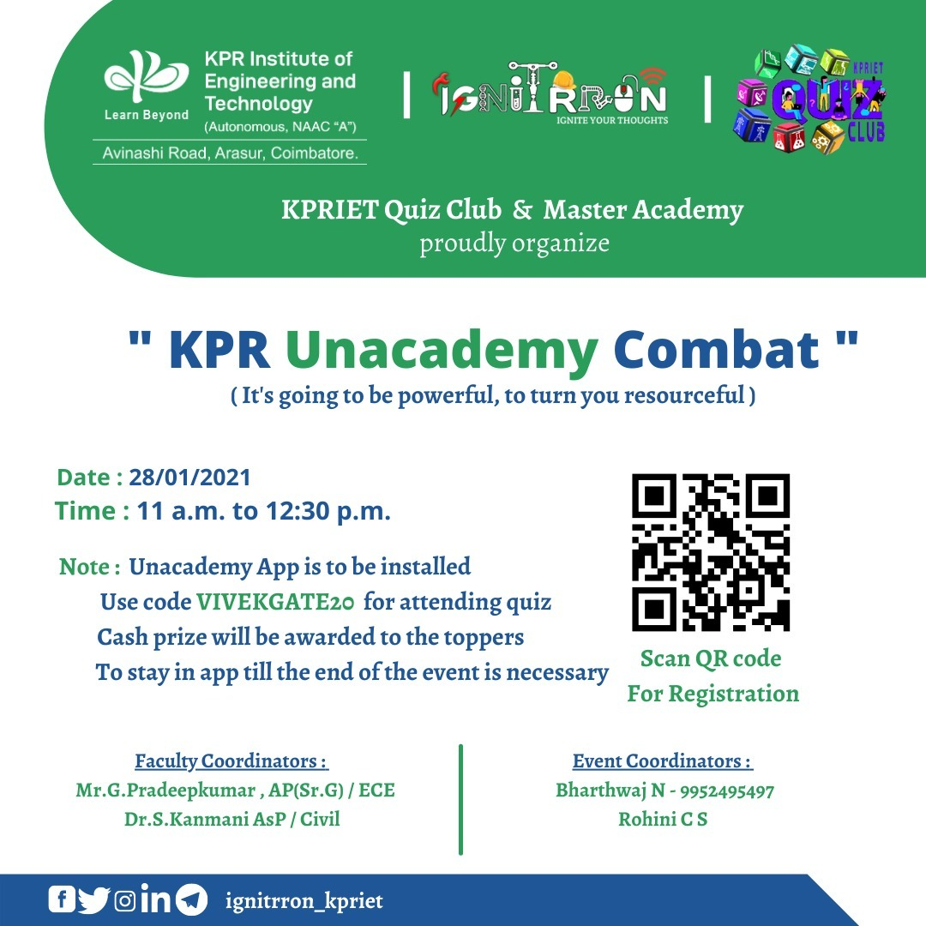

**Responses:**

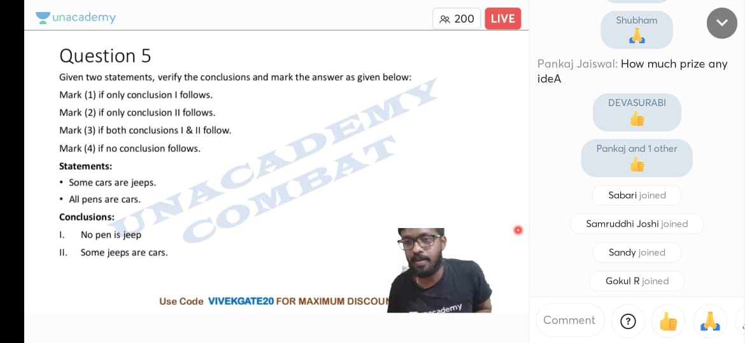

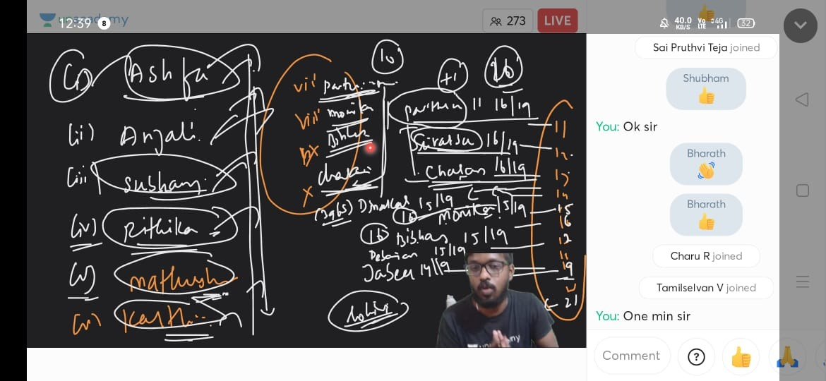

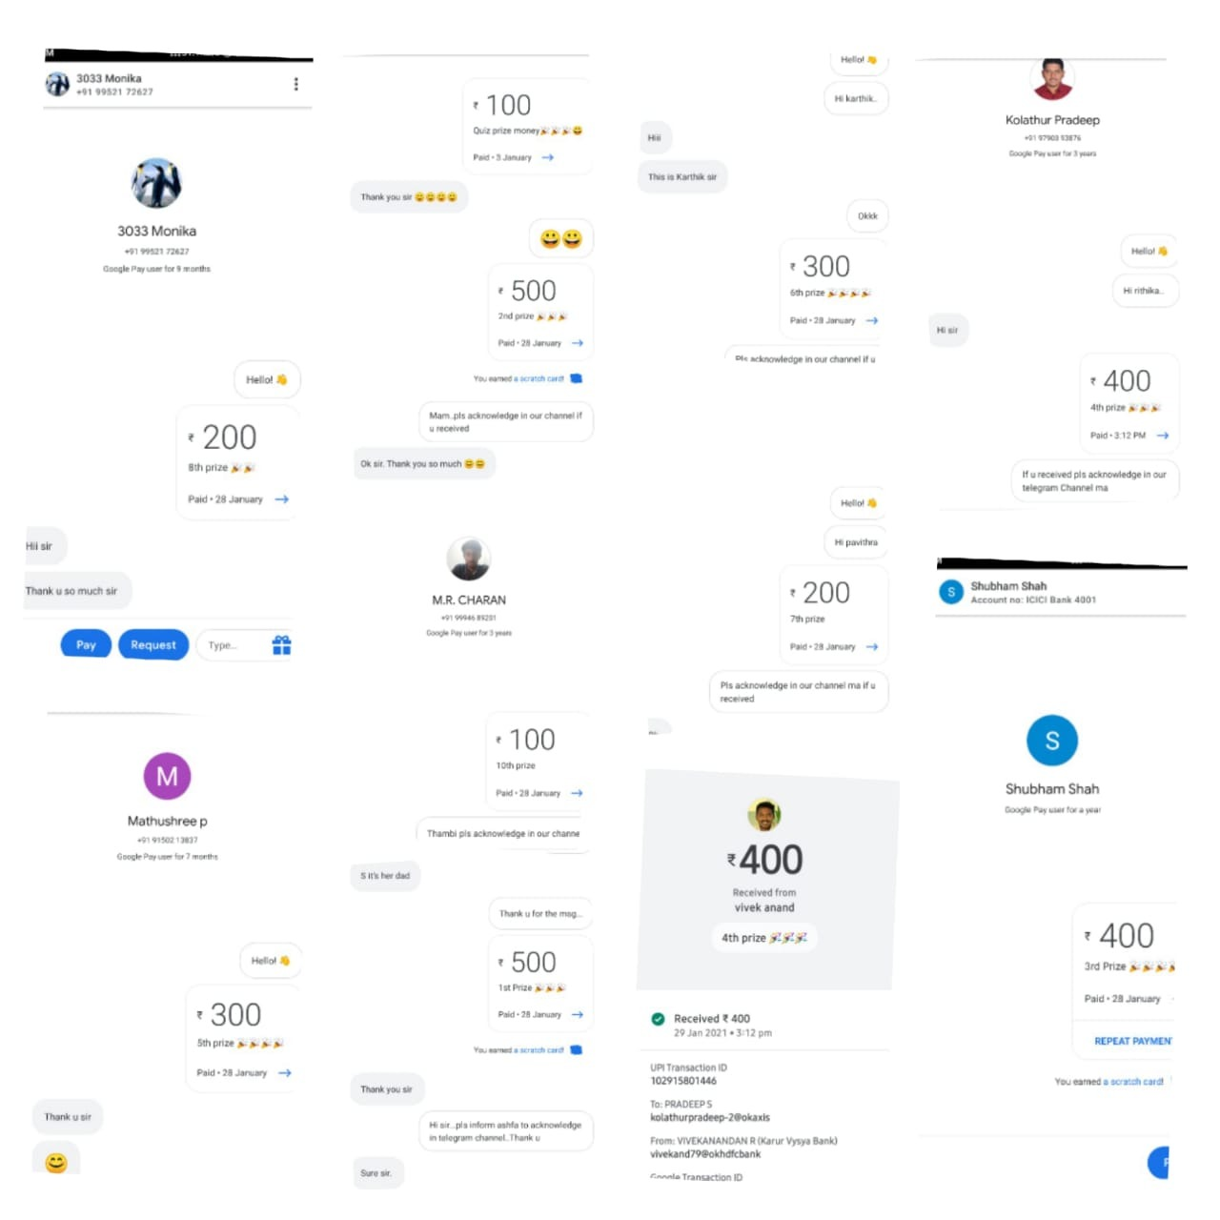

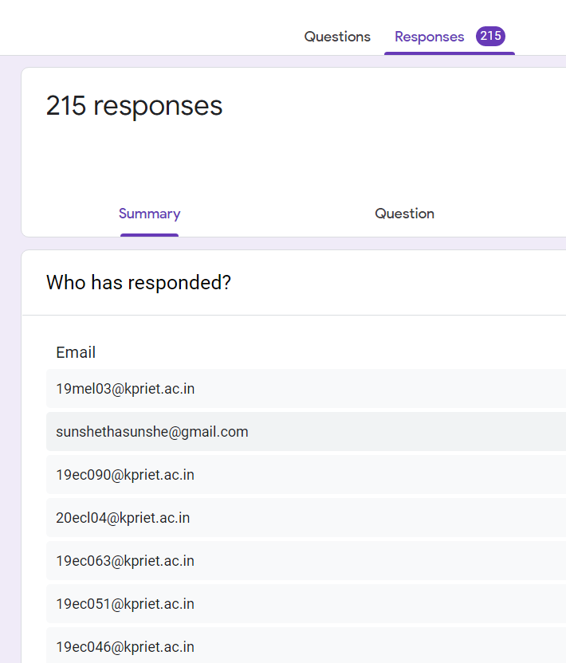

**Certificate Model:**

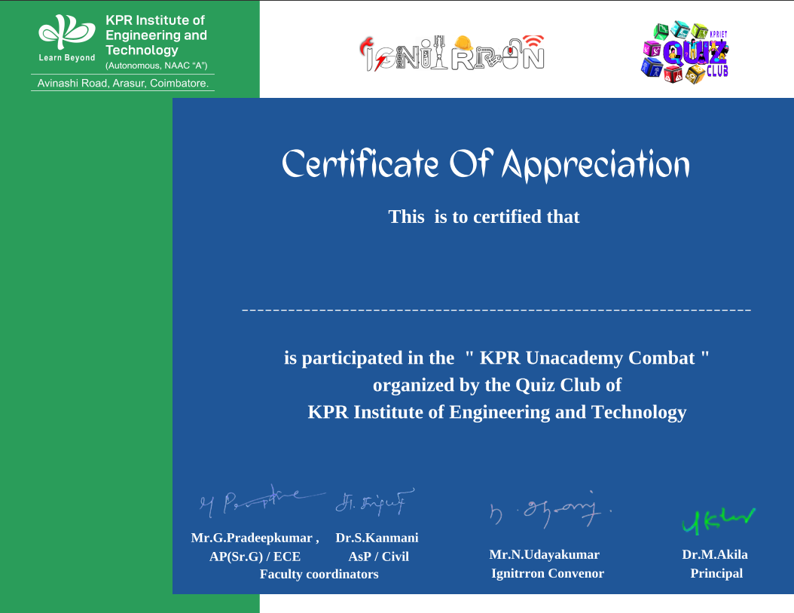

***THE END***